**PROJECT – 1**

|  |  |
| --- | --- |
| YUG | 2021KUCP1110 |
| OWAIS | 2021KUEC2028 |
| VAISHNAVI | 2021UEE1309 |

Q1. A push-button switch and an LED is connected to Arduino UNO. When we press the switch, the LED will glow. Simulate this circuit on tinkercad

<https://www.tinkercad.com/things/jDGs6qrVo5h-super-maimu-bojo/editel?sharecode=K5pR5c_vmAySEifiHcFoW-HxnTf8Gc0rS875-jcS_dI>

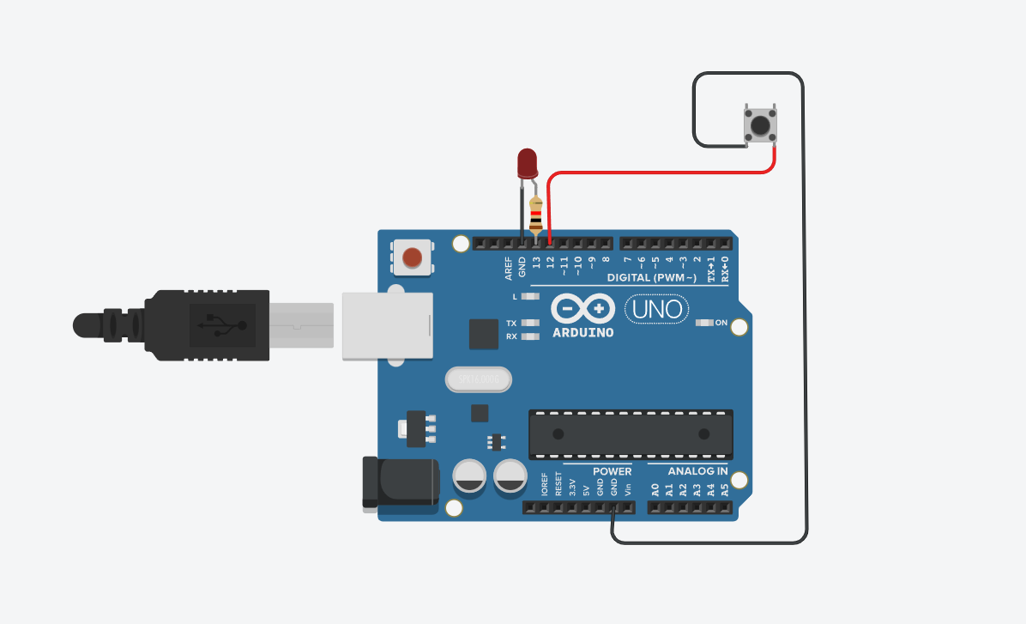

Q2. Simulate the circuit of controlling a servo motor using a potentiometer on tinkercad

<https://www.tinkercad.com/things/gBMQeJLcmmM-shiny-turing-rottis/editel?sharecode=eVanDMv9CnmlgP5mhLRqOUoHlirXFN0ZnYBjth31HvM>

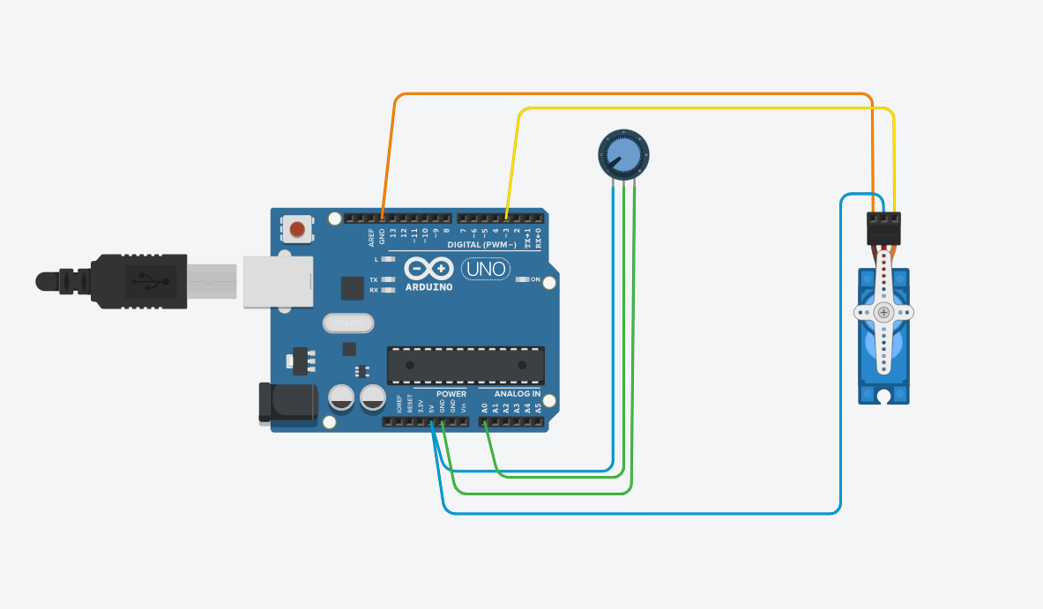

Q3 Program code to generate custom PWM signals on Arduino for an embedded system. Also, design a PCB of the same on Kicad

A. Controlling LED intensity using PWM registers directly. (**without** using analogWrite function)

<https://www.tinkercad.com/things/l5ogyIUAu07-epic-stantia-leelo/editel?sharecode=_FxK1l2x6IEZqWRRra1tm37iQ0meDK6bwL5BJwZnfWI&sharecode=_FxK1l2x6IEZqWRRra1tm37iQ0meDK6bwL5BJwZnfWI>

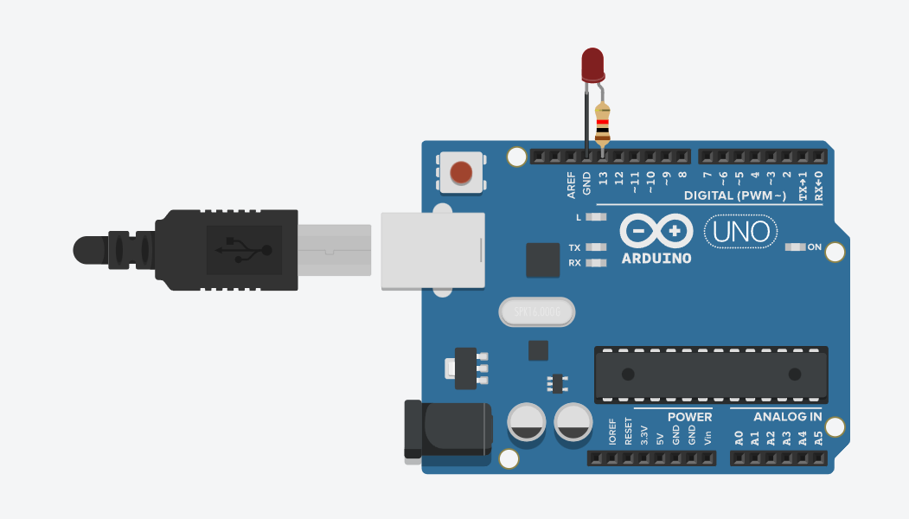

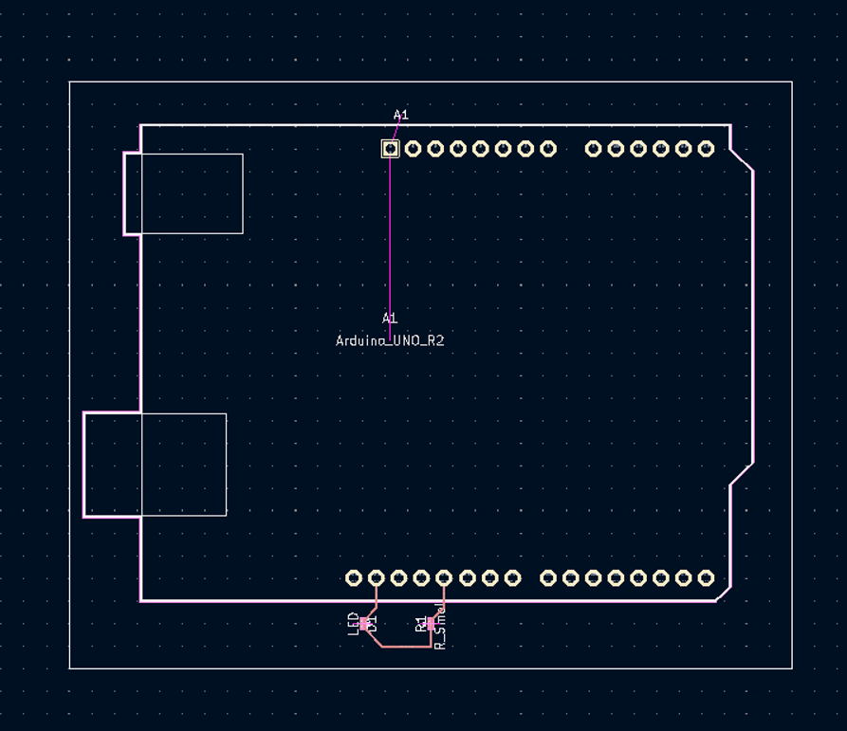

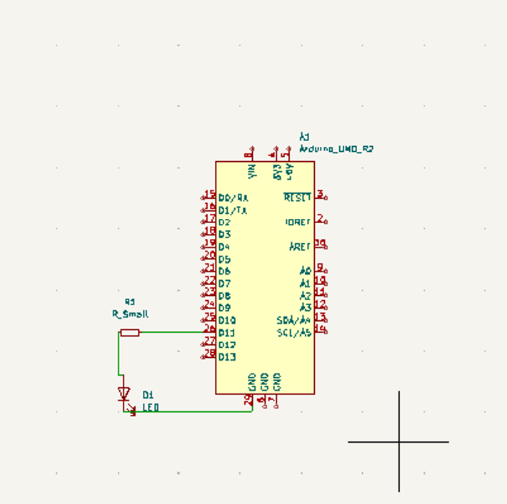

B. Sweep a servo without using the Servo library controlled with IR remote.

(Press 1 for right sweep ie from 0 to 180 degree and 2 for reverse)

<https://www.tinkercad.com/things/ltUnzvQjCFJ-fantastic-jaban/editel?sharecode=QcAZxm7L6_WzL_JVShRf56v358cClmjUApzCNEI8Tsg&sharecode=QcAZxm7L6_WzL_JVShRf56v358cClmjUApzCNEI8Tsg>



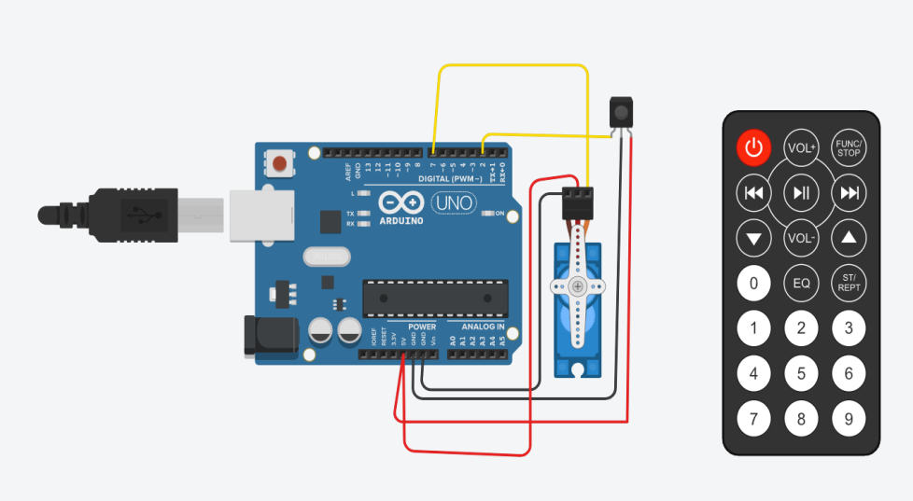

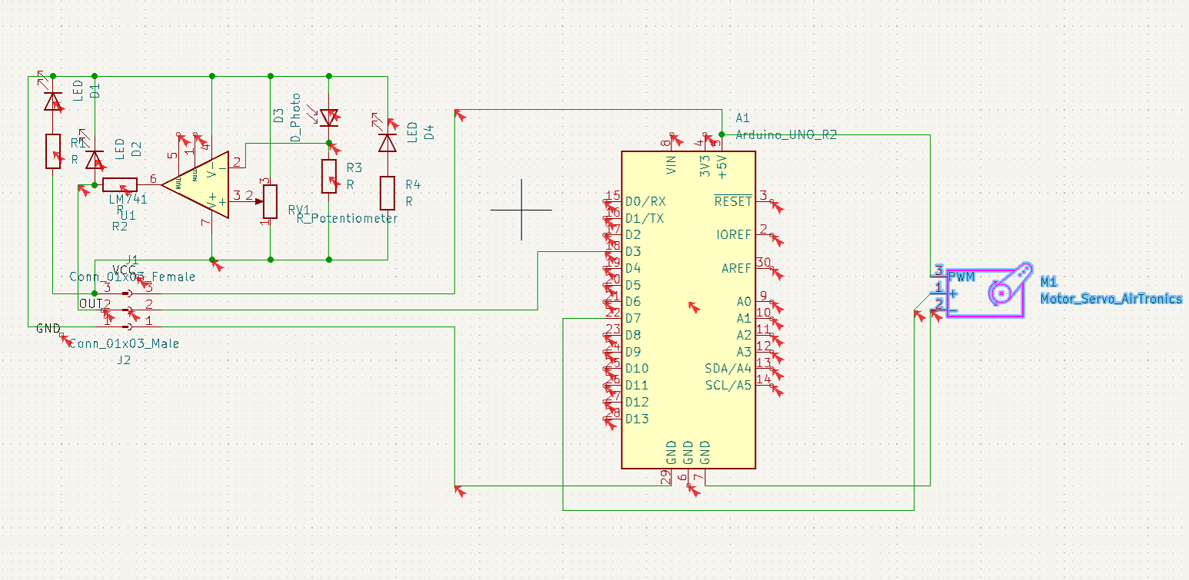

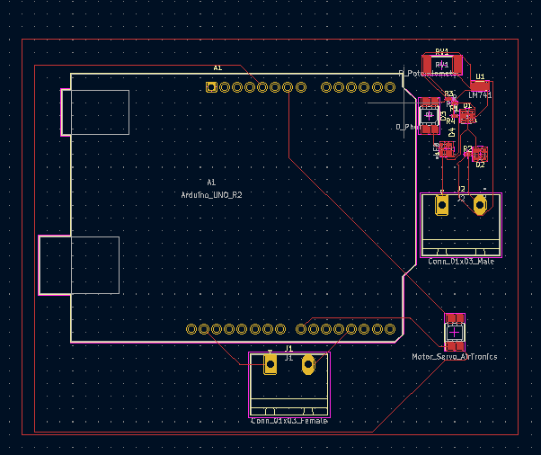

C. Design a custom PCB containing an Arduino Nano, IR receiver(for receiving signals from remote), Buck converter (for powering servo and Nano), a connector for servo and a connector for 12V power supply.



